RESOLUTION NO.__________

RE: CERTIFICATE OF APPROPRIATENESS UNDER THE
PROVISIONS OF THE ACT OF THE PENNSYLVANIA
LEGISLATURE 1961, JUNE 13, P.L. 282 (53
SECTION 8004) AND BETHLEHEM ORDINANCE NO.
3952 AS AMENDED.

WHEREAS, it is proposed to replace the fence along Center St. and Milton St., the interior fence and arbor at 72 E. Market St.

NOW, THEREFORE, BE IT RESOLVED by the Council of the City of Bethlehem that a Certificate of Appropriateness is hereby granted for the proposal.

Sponsored by: (s)

(s)

ADOPTED BY COUNCIL THIS DAY OF

(s)
President of Council

ATTEST:

(s)
City Clerk

HISTORICAL & ARCHITECTURAL REVIEW BOARD

The applicant is proposing to replace the fence along Center St. and Milton St., the interior fence and arbor at 72 E. Market St.
APPLICATION #2:

Lori & Rod Young
72 E. Market St.
Bethlehem, PA 18018

OWNER:

__________________________________________________________________________

The Board upon motion by Marsha Fritz and seconded by Diana Hodgson adopted the proposal that City Council issue a Certificate of Appropriateness for the following:

- New fence will be board on board with an interior fence to match existing fence.

- Curved arbor to be replaced with flat top arbor.

- Wood to be natural and posts will have copper caps.

4. The motion was unanimously approved.

__________________________________________________________________________

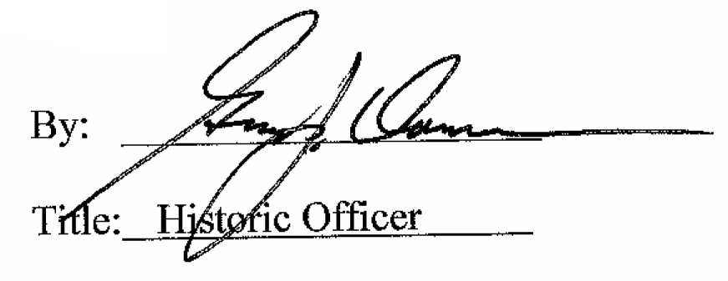

Date of Meeting: May 3, 2017

